

National Technical University of Athens

School of Civil Engineering

Acad. Year: 2020-2021

**Course: Stochastic Finite Element methods**

2nd Assignment

Consider the following plane stress problem

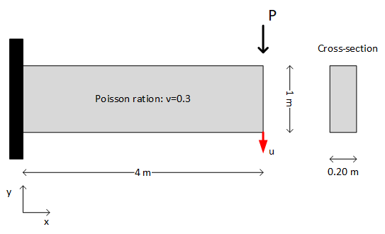

where $P$ is a random variable following the Gaussian distribution $Ν(10,2)$ (kN) and the modulus of elasticity $E$ is a random field given by the following formula:

$$E\left(x\right)={10}^{5}\left(1+0.10f\left(x\right)\right) (kN/m^{2})$$

with $f\left(x\right)$ being a zero-mean stationary Gaussian field with unit variance. The autocorrelation function for $f$ is $R_{f}(τ)=exp⁡(-|τ|/3)$.

1. *Develop a FE code for solving the deterministic problem using quadrilateral elements and a 40 x 10 mesh.*
2. *Using the KL series expansion, generate 5000 realizations for $E(x)$ and perform Monte Carlo simulation to obtain the histogram of the response $u$, at the bottom right corner of the cantilever.*
3. *Convert the histogram to an empirical probability density function.*